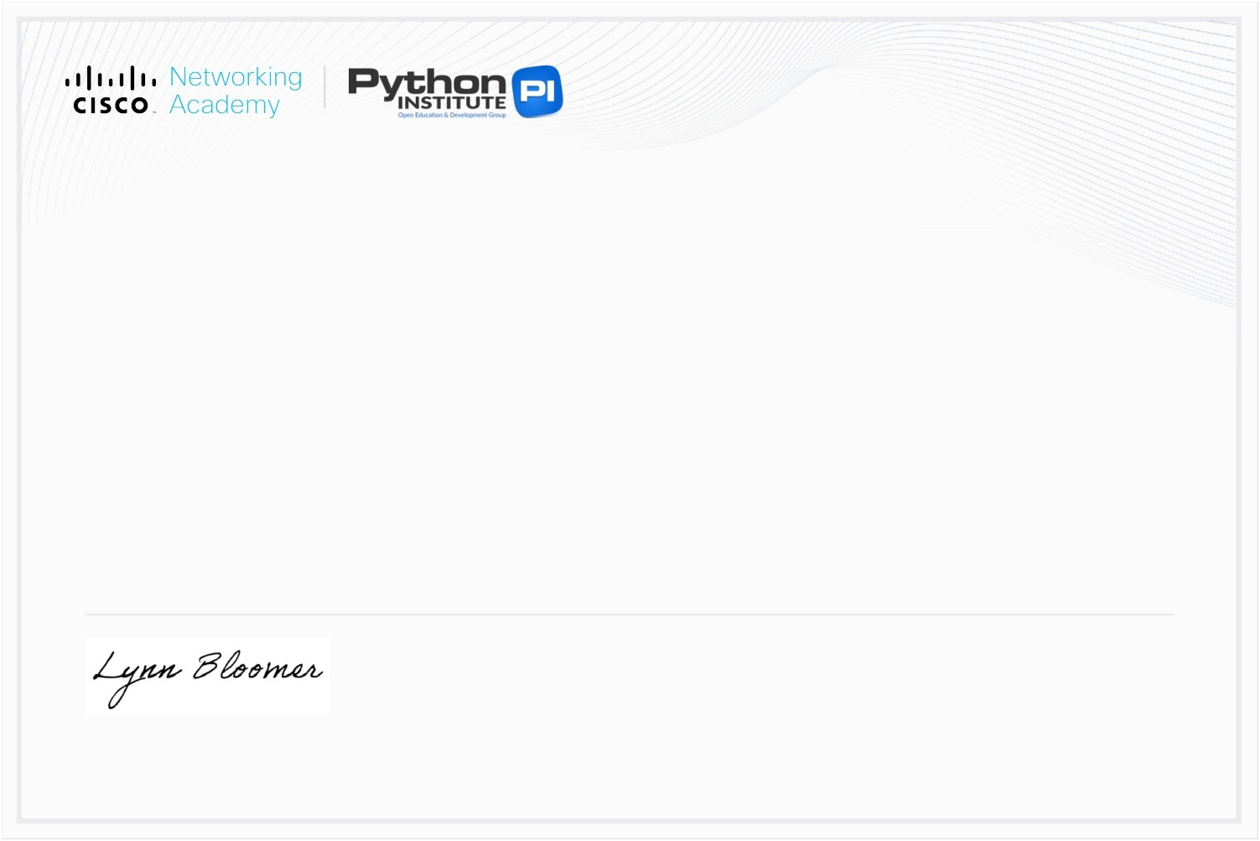
This

certificate

is

awarded

to
Vansh Sharma
for

successfully

completing
Python

Essentials

1
offered

by

Networking

Academy
through

the

Cisco

Networking

Academy

program.
Lynn

Bloomer

Dire
ctor
Cisco

Networking

Academy

15

Feb

2026
Completion

Date

